OUTPUT

ASG1

ASG2

# Lab Session

1. Create a Navigation menu bar with dropdown list (10 Marks)
   1. Create header
   2. Create a nav bar with link 1, link 2, link 3.
      1. When hovering over link 2 and 3, show a drop down menu for each of them with DD_Link_1,DD_Link_2,DD_Link_3
      2. Apply all the required css properties like width, height, hovering properties, etc.,

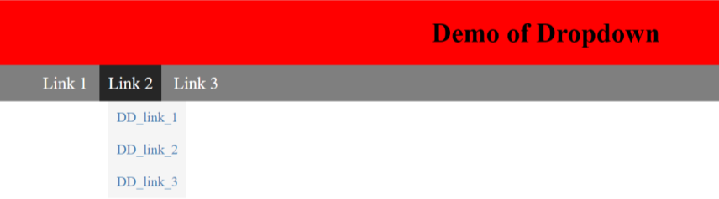

1. Create a vertical bar graph with the help of animation. (10 Marks)
   1. when the page is opened/refreshed, the bar should move from bottom to top, to a predefined percentage. Mention the percentage name below. Create 3 such graphs with 30%, 40% and 80%.
   2. Below percentage print h1 with text “Bar Plot”
   3. Chart, bar chart

      Description automatically generatedPosition it in the centre of the page.

CheckList

Asg1.

* DONE - Header Tag
* DONE - Navigation Bar with 3 Links
* DONE - 2 Links as DropDowns –
* DONE - DropDown Items must have Hovering CSS function
* DONE - all the required css properties like width, height, hovering properties

CheckList

Asg2.

* DONE Animation on page open and Refresh
* DONE Percentage specified
* DONE Center aligned
* DONE TEXTS

# ID Navigate

# Header and h1

Header and h1 is tag so check syntax in CSS.

# Tags and CSS

# Menu Class and Actions

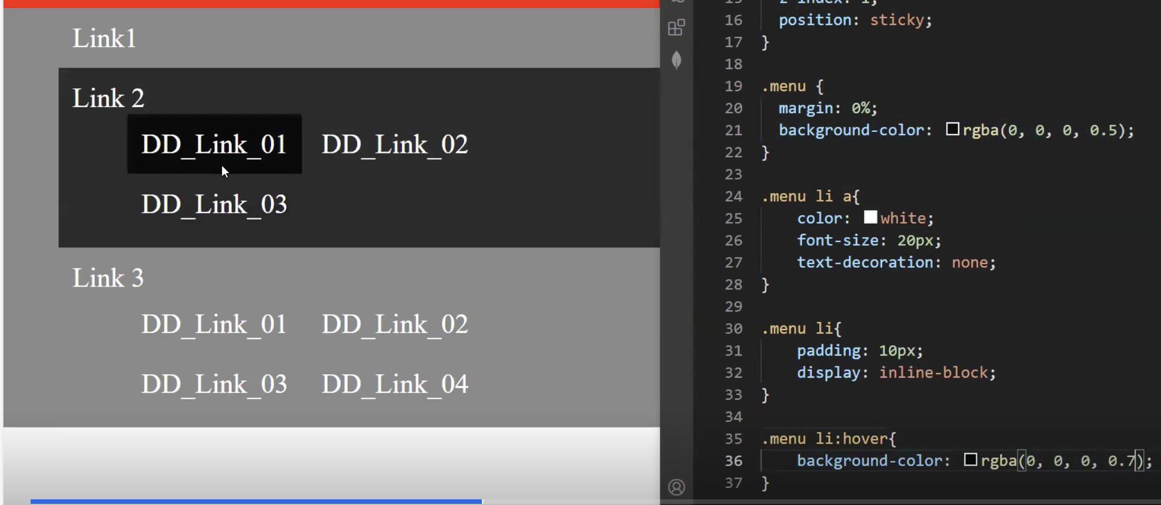

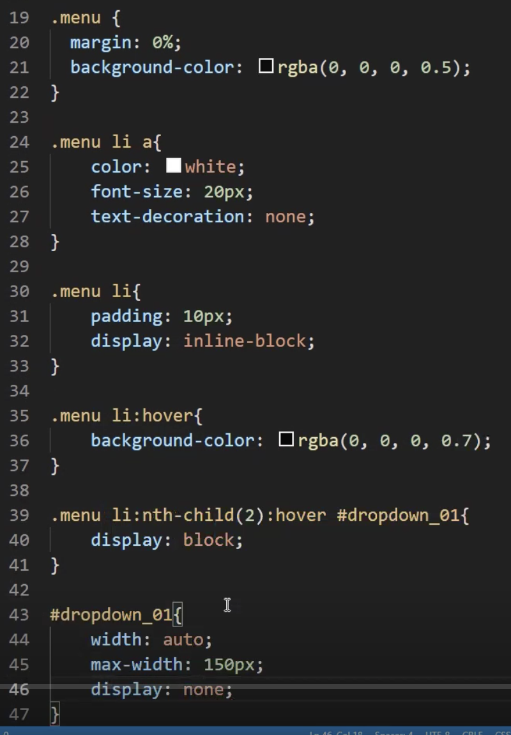

Display none by default for the Drop Down